REG NO: SCS3/147863/2024
NAME : KAMAU DAVID

WEKA ASSIGNMENT Q3
Using the diabetes dataset OR heart dataset (select either from the weka list of datasets).
Study the dataset first. Now set the Training/Testing data partition as 70%/30%.
We will compare 2 algorithms – kNN and J4.8 on classification

(a) Obtain the accuracy and record the confusion matrix. Use the default algorithm settings.

ANS:
The Diabetes dataset was used for this assignment

J48 Algorithm
Correctly Classified Instances – 76.5217%
Confusion Matrix :
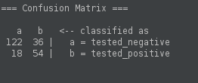

IBk Algorithm
Correctly Classified Instances – 73.4783%
Confusion Matrix :
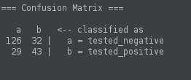

(b) From the confusion matrix, which class appears to be more difficult to classify for each of the
datasets?

ANS:
Based on the confusion matrices above, the tested_positive (class b) is the more difficult class to classify for both algorithms.

This is because :
For J4.8, the error rate for predicting negative cases (class a) is roughly 22.8% (36 errors out of 158) while the error rate for predicting positive cases (class b) is higher at 25.0% (18 errors out of 72).
For kNN (IBk), the error rate for predicting negative cases is roughly 20.3% (32 errors out of 158). The error rate for predicting positive cases is significantly higher at 40.3% (29 errors out of 72).

From the above information, we can safely say that both algorithms struggle more with positive cases, likely because there is less training data available for that specific class.

(c) Change some parameters in each of the algorithms and note if the performance improves.

ANS:

Summary:
J4.8: Changing the parameters did not improve performance. Increasing the minNumObj to 10 and 15 actually caused the accuracy to drop to 75.6522%. The best accuracy remains the default at 76.5217%.
kNN (IBk): Changing the parameters did improve performance. Increasing the K-value to 5 raised the accuracy from the baseline of 73.4783% up to 74.7826%.

Detailed explanations are here below:-
Tuning J48:
- Changing minNumObj parameter from 2 to 5
The accuracy i.e. Correctly Classified Instances still remains at 76.5217%.
Its Confusion Matrix :
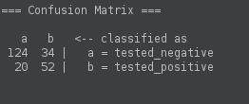

- Changing minNumObj parameter from 5 to 10
The accuracy i.e. Correctly Classified Instances drops to 75.6522%.
Its Confusion Matrix :
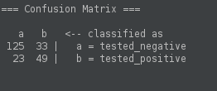

- Changing minNumObj parameter from 10 to 15
The accuracy i.e. Correctly Classified Instances drops to 75.6522 %.
Its Confusion Matrix :
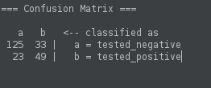

Tuning Ibk:
- Changing the Knn parameter from 1 to 3
The accuracy i.e. Correctly Classified Instances still remains at 73.4783 %.
Its Confusion Matrix :
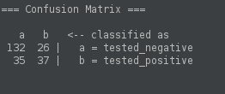

- Changing the Knn parameter from 3 to 5
The accuracy i.e. Correctly Classified Instances rises to 74.7826 %.
Its Confusion Matrix :
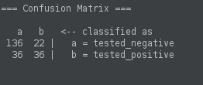

- Changing the KNN parameter from 5 to 7
The accuracy i.e. Correctly Classified Instances drops to 73.0435 %.
Its Confusion Matrix :
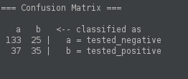

(d) Of these two algorithms, which one is the better classifier?
ANS:
J4.8 is the better classifier for this specific dataset and split. Even after optimizing kNN to its best performing state (K=5), it still could not beat the baseline decision tree.

(e) Using the three most relevant attributes as can be depicted from Decision tree algorithm,
now create a KNN model and note if the performance improves. (You can do this by
removing some attributes by checking them off when viewing the dataset)
Document your results clearly.

ANS:
1. Identification of Relevant Attributes
Based on the root and primary nodes of the J48 decision tree model generated in section (a), the three most highly predictive attributes for this dataset were identified as plas, mass, and age.
2. Methodology
To conduct feature selection, the dataset was filtered to retain only these three critical attributes alongside the target class label. All other attributes were removed to eliminate potential dimensionality noise.
The IBk (kNN) algorithm was then re-evaluated on this reduced feature space using the established 70%/30% training and testing data partition.
3. Results and Observations
The impact of feature selection on the model's performance varied significantly depending on the hyperparameter K (number of nearest neighbors):
- When K = 1 (Default): The classification accuracy decreased from the baseline of 73.4783% down to 70.8696%.
- When K = 5 (Tuned): The classification accuracy improved from the previous optimum of 74.7826% up to 75.2174%.
4. Conclusion
Feature selection successfully improved the overall performance of the kNN classifier, but only when the algorithm was appropriately parameterized. Removing less relevant attributes reduces noise, which allows the kNN algorithm to calculate more meaningful distance metrics between data points.
However, in this compressed feature space, relying on a single neighbor (K=1) rendered the model overly sensitive to local outliers, causing a drop in accuracy. By utilizing a more robust neighborhood consensus (K=5) alongside the filtered data, the model achieved its highest kNN accuracy of 75.2174%.

